PHYS1401 Midterm#1 (105/100 pts)
NOTE(IMPORTANT!!): Please detach, sign, and submit the equation sheet to receive credit.
Print Name:__________________________________________________________________________
NetID:___________________________ Course Section:______________________________________
Part I: Multiple-choice Questions (Only the answer shall be credited. Each question has only one correct answer.)
- (5pts) The magnitude of vector $\vec{A}$ is 7 and the magnitude of vector $\vec{B}$ is 4. Which of the following statements is correct?
- The magnitude of $\vec{A}-\vec{B}$ must be 3.
- The magnitude of $\vec{A}+\vec{B}$ must be 11.
- The magnitude of $\vec{A}+\vec{B}$ can be 8.
- None of the above is correct.

- (5pts) A velocity vector $\vec{v}$ with its x- and y-components is shown in the diagram below. Which of the following options correctly represents the vector $\vec{v}$?
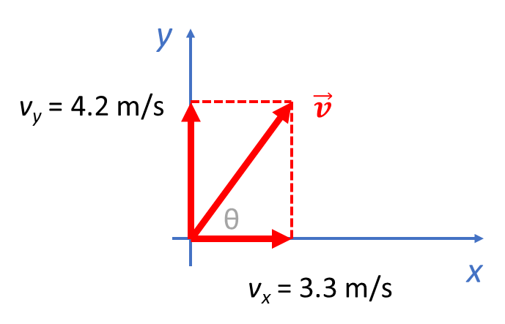
- $\vec{v}=5.3 m/s$
- $\vec{v}=(4.2m/s)\hat{i}+(3.3m/s)\hat{j}$
- $\vec{v}=(3.3m/s)\hat{i}+(4.2m/s)\hat{j}$
- $\vec{v}=(3.3m/s∙\cos{θ})\hat{i}+(4.2m/s∙\sin{θ})\hat{j}$

- (5pts) Using the following table of base quantities, determine the units of the quantity $\sqrt{ar}$. Select the single best answer.
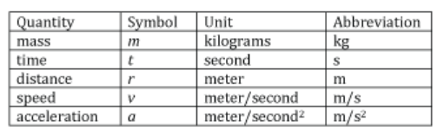
- m/s
- m³/s
- m³/(m ∙ s²)
- m²/s²

- (5pts) I need to drive along a straight path from point A to point C, passing through point B. The distance from A to B is 15 miles, and the distance from B to C is 62 miles. On the first leg of the trip, from A to B, I average a speed of 33 mph. On the second leg, from B to C, my average speed is 57 mph. What is my average speed for the entire trip?
- 50 mph.
- 47 mph.
- 45 mph.
- 43 mph.

- (5pts) The length of a racetrack is d. A tortoise runs with a constant speed v_{T}, and a hare runs with a constant speed v_{H}. Assuming both the tortoise and the hare maintain their speeds throughout the race, which of the following symbolic representations correctly expresses the time it takes for the hare to finish the race?
- d/v
- d/v_{T}
- s/v
- d/v_{H}

- (5pts) A rock is thrown straight upward. Neglect air resistance. Which of the following statements is correct?
- The direction of its acceleration is downward when it is rising.
- The direction of its velocity is downward when it is rising.
- The acceleration is zero when it reaches its highest point.
- The direction of its acceleration is upward when it is rising

- (5pts) An object initially at rest on a flat, frictionless surface experiences a linearly increasing force. As a result of this force, the object's acceleration varies with time as shown in the Acceleration vs. Time plot below:
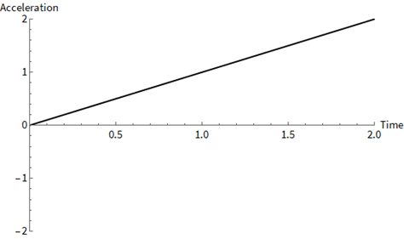
Given the Acceleration vs Time plot above, which is the correct Velocity vs Time plot?
A | 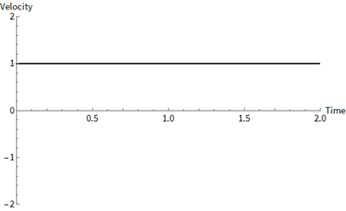 | B | 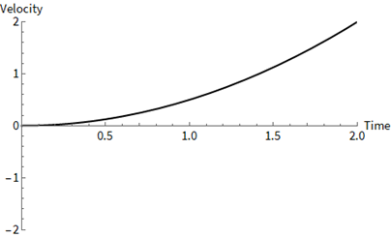
C | 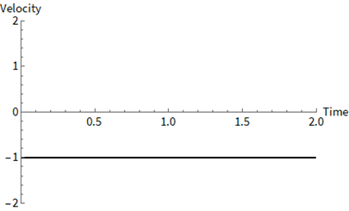 | D | 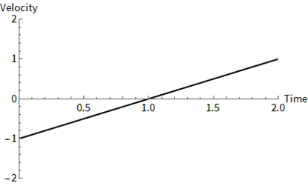

- (5pts) A spaceship is traveling at a velocity of ${\vec{v}}_{0}=\left(18.7 m/s\right)\hat{i}$ when its rockets fire, giving it an acceleration of $\vec{a}=\left(2.45m/{s^{2}}\right)\hat{i}+\left(3.69m/{s^{2}}\right)\hat{j}$. What is the y-component of the spaceship's velocity after the rockets have fired for 3.05 seconds?
- 29.3 m/s
- 11.3 m/s
- 26.2 m/s
- 18.7 m/s

The next two questions are based on the following situation: A football player runs for a distance d₁ = 6.50 m in 1.20 s, at an angle of θ = 35.0 degrees to the 50-yard line, then turns left and runs a distance d₂ = 12.00 m in 1.10 s, in a direction perpendicular to the 50-yard line. The diagram shows these two displacements relative to an x-y coordinate system, where the x axis is parallel to the 50-yard line, and the y axis is perpendicular to the 50-yard line.
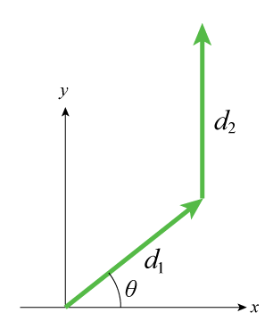
- (5pts) What is the average speed?
- 7.80 m/s
- 8.04 m/s
- 8.91 m/s
- 6.95 m/s

- (5pts) What is the magnitude of the total displacement?
- 12.7 m
- 16.6 m
- 14.8 m
- 19.2 m

Multiple Choice Section Total: /50
Part II: Problem-solving Question (Please present the complete problem-solving procedure. Answers with no supportive calculation shall not be credited)
- (20pts) A student launches a small rocket straight up from rest at ground level. The rocket accelerates at a constant rate of 19.2 m/s² for 13.3 seconds until it runs out of fuel. Using the five-step problem-solving approach, determine the time it takes for the rocket to reach its maximum height.

Question 11 Total: /20
- (15pts) A particle moves along the x axis and its position as a function of time is x(t) = (18.6 m/s)t - (1.81 m/s²)t².
  - (5pts) Determine all the times when the particle is at x = 0.

  - (5pts) Determine all the times when the instantaneous velocity of the particle is 0 m/s.

  - (5pts) What is the magnitude of the particle's acceleration?

Question 12 Total: /15
- (20pts) A student standing on a cliff that is a vertical height 12.3 m above the level ground throws a stone with velocity 23.0 m/s at an angle 19.2 ° below horizontal. The stone moves without air resistance; use a Cartesian coordinate system with the origin at the stone's initial position.
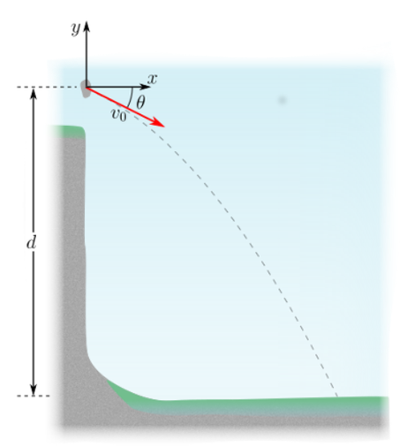
  - (5pts) According to the given coordinate system, what is the y-coordinate of the stone when it strikes the ground?

  - (5pts) How much time does the stone take from the moment it is thrown until just before it reaches the ground?

  - (10pts) Find the magnitude of the velocity right before the stone strikes the ground.

Question 13 Total: /20

Equation Sheet
Gravitational acceleration: g = 9.8 m/s²

The following five equations could also be applied to y- or z-direction, with a proper subscript modification:
Acceleration along x-direction: $a_{x}=\frac{dv_{x}}{dt}$
Velocity along x-direction: $v_{x}=\frac{dx}{dt}$

1D constant velocity motion: $x=x_{0}+v_{0x}t$
1D constant acceleration motion: $v_{x}=v_{0x}+a_{x}t$ and $x=x_{0}+v_{0x}t+\frac{1}{2}a_{x}t^{2}$

Average acceleration/velocity/speed: ${\vec{a}}_{avg}=\frac{{\vec{v}}_{f}-{\vec{v}}_{i}}{t_{f}-t_{i}}$ ${\vec{v}}_{avg}=\frac{{\vec{r}}_{f}-{\vec{r}}_{i}}{t_{f}-t_{i}}$ $v_{avg}=\frac{d_{total}}{t_{total}}$

